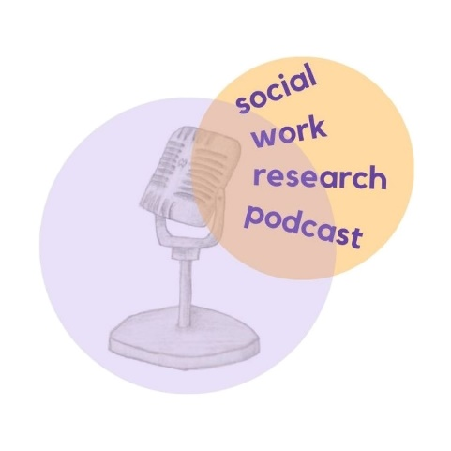
Recording your podcast reflections

Each episode of the Social Work Research Podcast features an in-depth discussion about a research paper. The podcast aims to make social work research more accessible and engaging. All episodes are available here: https://martinwebber.net/socialworkresearchpodcast.
This template has been designed to support learning and reflections from podcast episodes. It provides some questions to consider as you are listening and a space for your notes. It can also support conversations about the research with colleagues and recording of your CPD (requirements of re-registration with Social Work England).
More information about the CPD requirements of Social Work England can be found here.
Title of paper
Background
What was the context for the research? What were the research questions?
Methods
What methods were used? What were the strengths and limitations of the methods used?

Findings
What were the results of the research? What is new from these findings?
Implications for my practice
What have I learnt from listening to this podcast / reading this paper? What does this mean for my practice? What do I wish to discuss further with my colleagues?

